Assignment -1

# Objective:

To create a basic virtual environment in Unity that includes a ground plane, a skybox, environmental objects, lighting, and simple VR interaction. The player should be able to grab and move the grabale objects in the environment

# Guidelines:

* Try to complete as many tasks as possible.
* Each task will earn some points denoted in the corresponding brackets.
* Submit the final Project as a github repo.
* Create one document with screenshots and explanation of each task.
* Create a screen record to show the demo of the task completed.
* Modify your gamelogic in the given C# scripts.

**Task 1:** Set Up Your Unity Project & Configure the VR Environment [5 marks]

# Create a New Unity Project

1. Open Unity Hub , Click on new project to create a project.

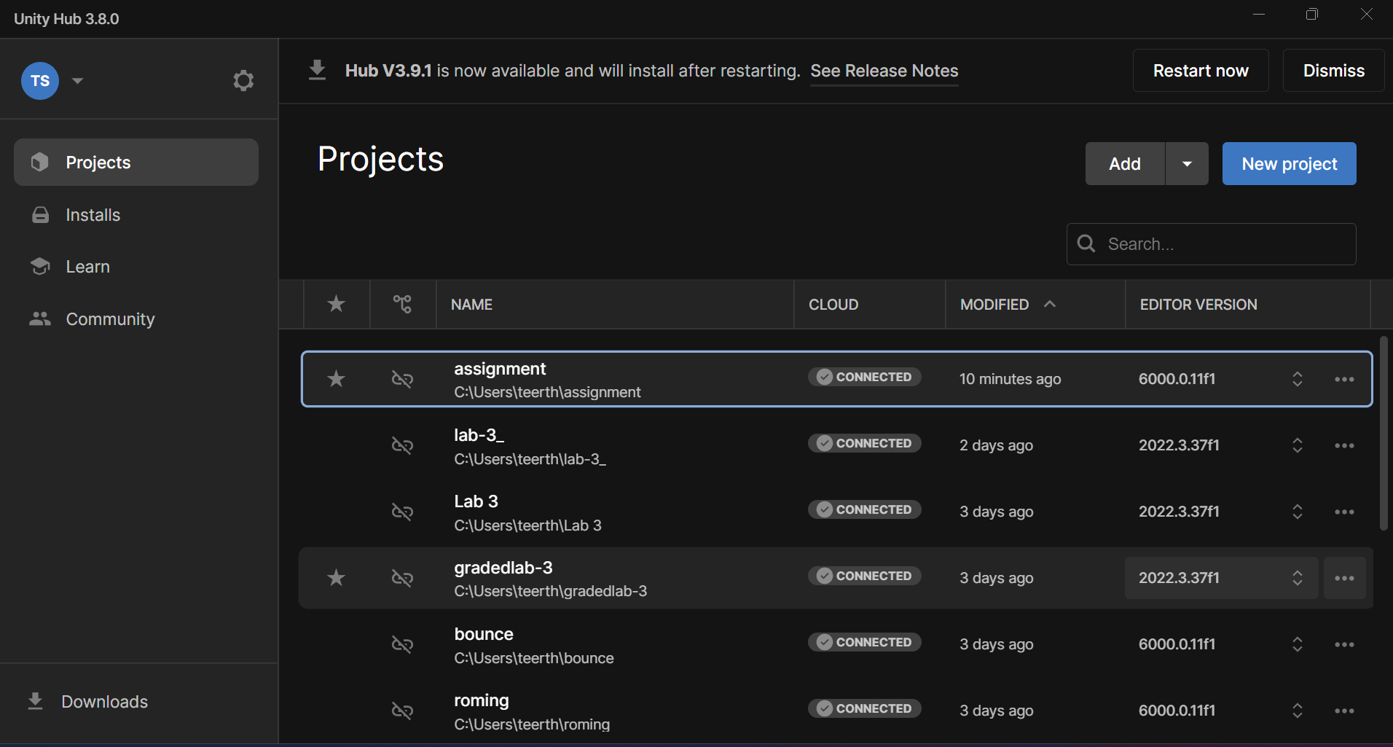

1. Click on “3D Build in Render Pipeline” template.
2. Set the project name, then click “Create Project.”

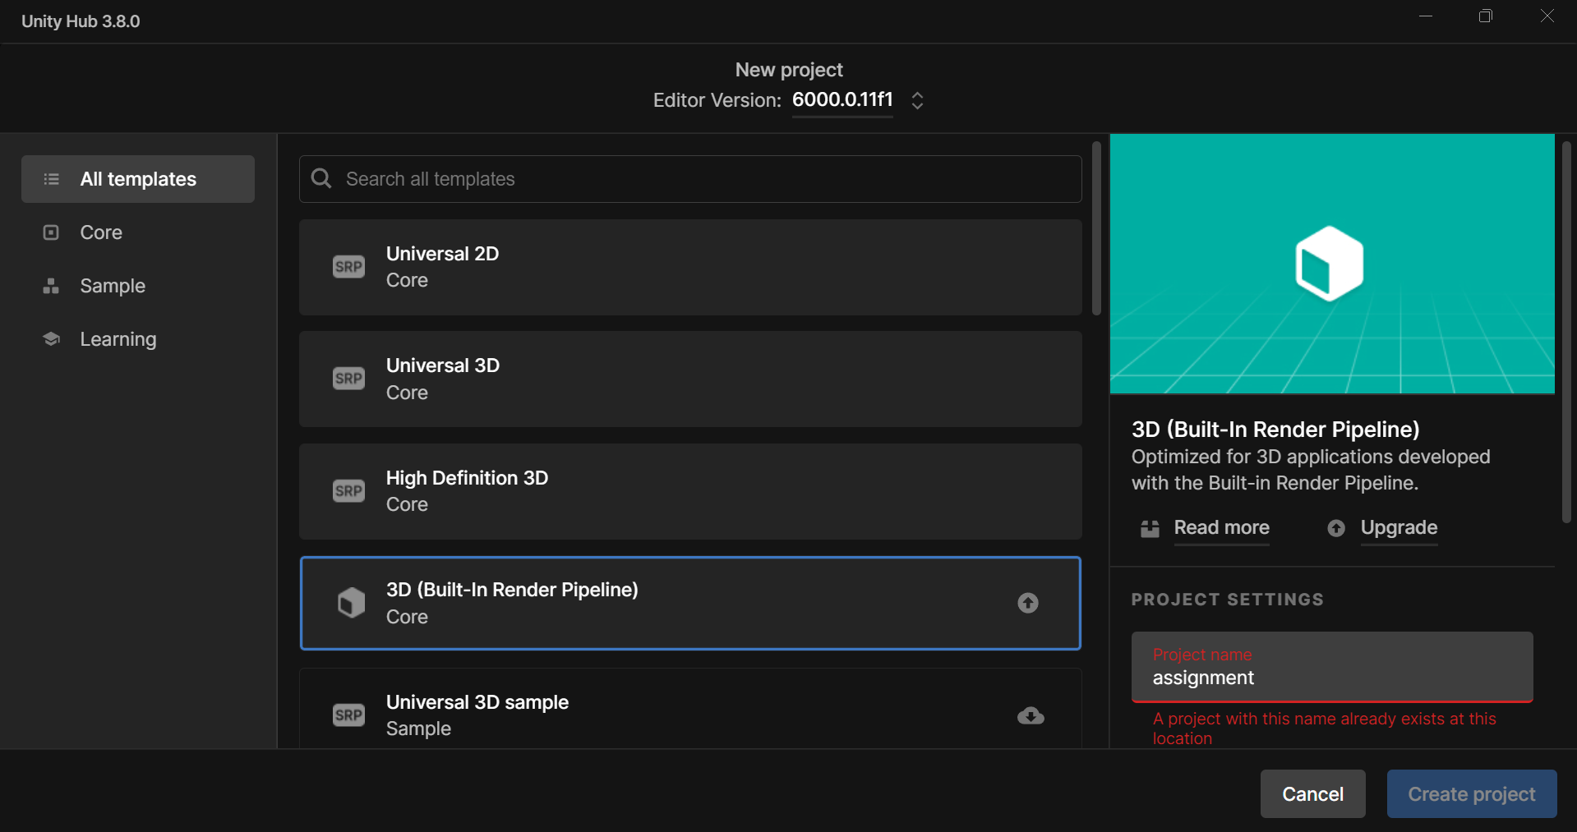

# Configure the VR Environment

1. In menu bar go to “Window” then go to “Package Manager.”

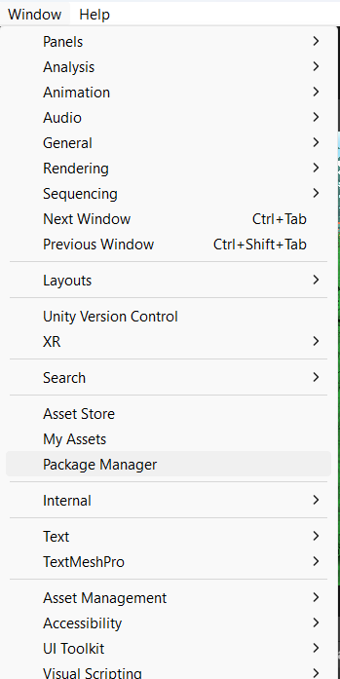

**THIS PAGE IS BLANK BECAUSE OF IMAGE RENDERING ISSUE.**

1. In “Package manager” go to “Unity registry” .
2. Search “XR Plugin Management” and install it.
3. By using same step install the “Oculus XR Plugin”.

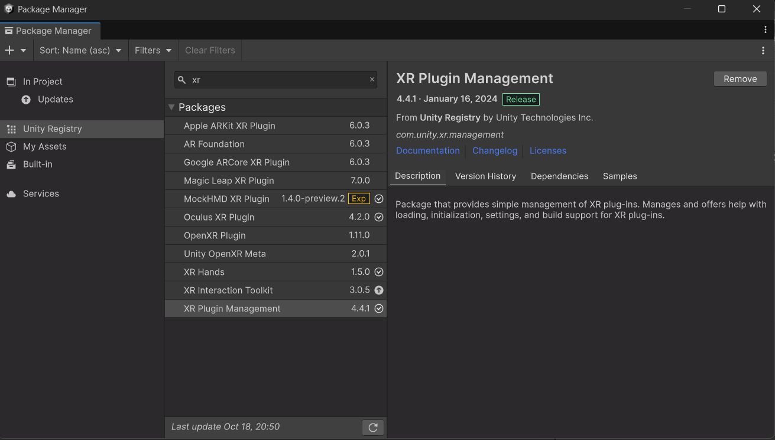

**Configure XR Settings**

1. Go to “Edit” in menu bar ,then go to “Project Settings” then go to “XR Plugin Management.”

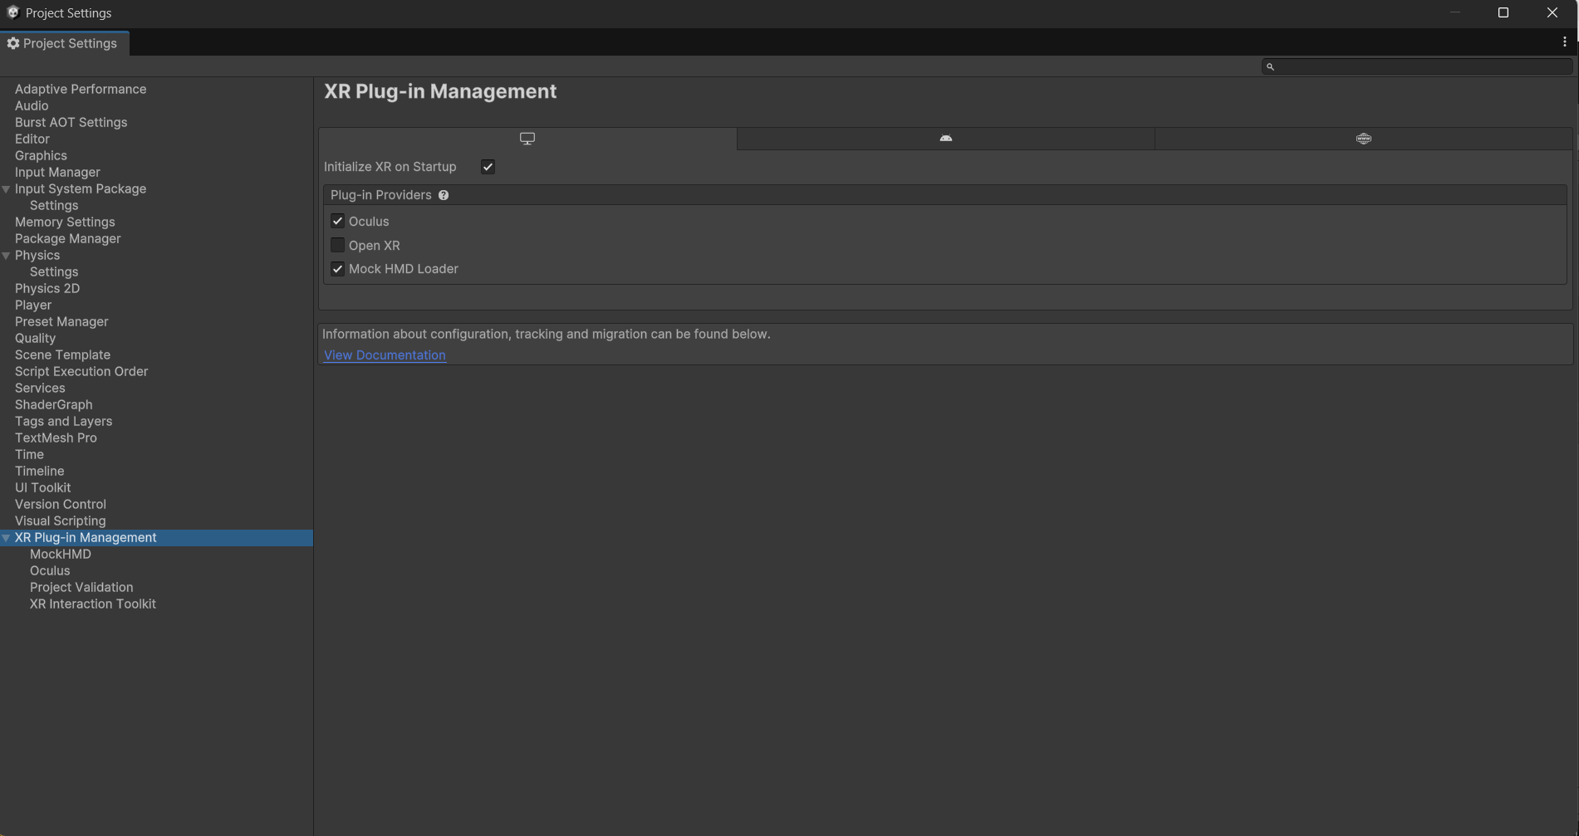

1. Select “Oculus” and “Mock HMD Loader”.
2. Use same selection for the Android platform and select the option “Initialize XR on Startup”.

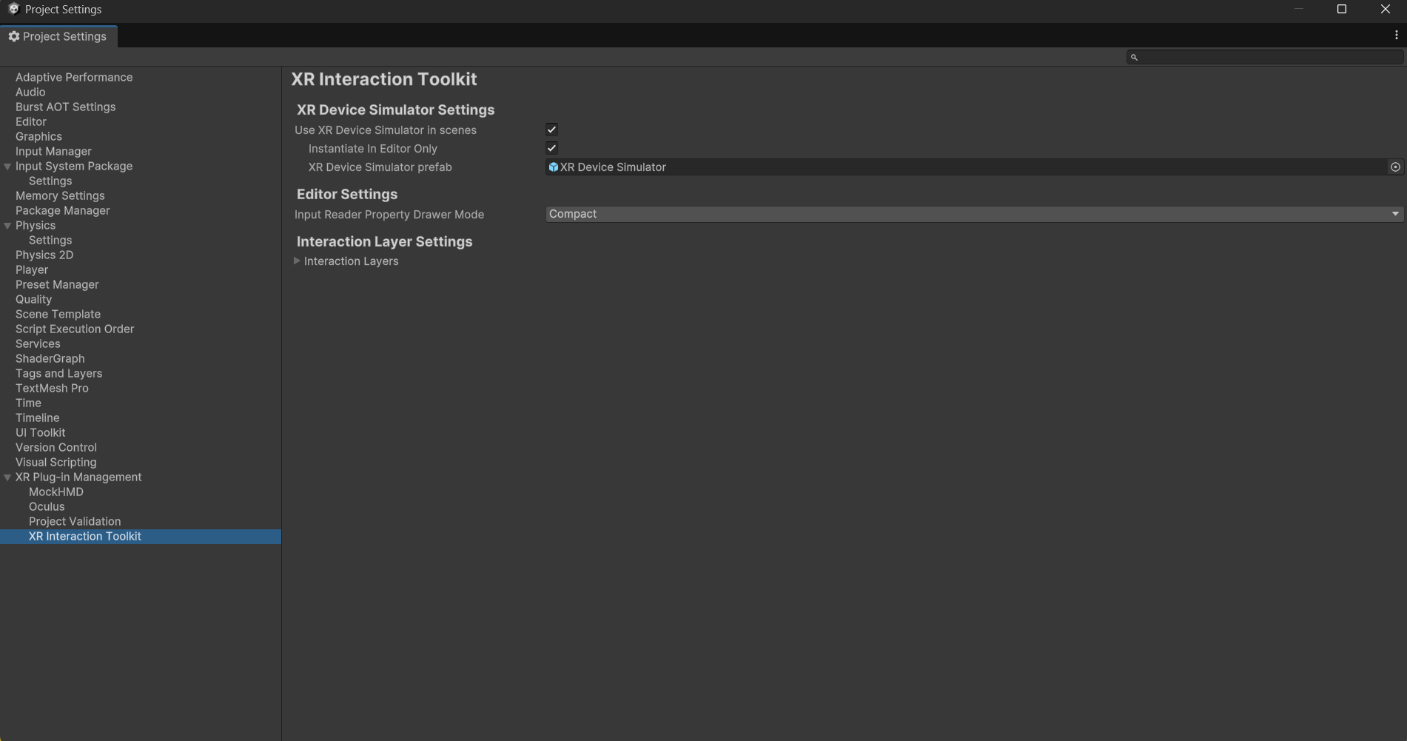

**Task 2:** Create the Ground Plane [5 marks]

* + Create a larger ground area so player can move around
  + You can use Terrain object for that

# Took the Asset for this task from Asset Store: -

<https://assetstore.unity.com/packages/3d/environments/lowpoly-environment-nature-free-medieval-fantasy-series-187052>

and loaded it in assignment Project

**Task 3:** Add a Skybox [5 marks]

* + You can use sky presets
  + Try to make it more detailed and more interesting

1. Add the Skybox to Your Scene
   * Open the Lighting window by going to Window > Rendering > Lighting.
   * In the Environment tab, you’ll see the Skybox Material section. Click on the little circle next to it, then pick the Skybox material you want to use from the list.

**Task 4:** Add Environment Objects [15 marks]

* + - You can use Assets to create an engaging Environment
    - Create a grabbable objects spawning at random locations

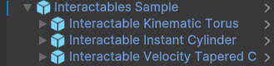

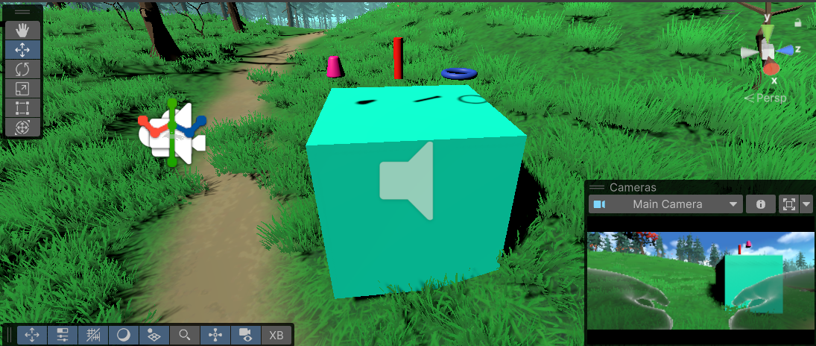

**Task 6**: Configure Lighting and Shadows [5 marks]

1. Set Up Your Lighting
   * Directional Light: Think of this as your main light source, like the sun. You can add it by going to GameObject > Light > Directional Light.
     + Adjust the Intensity to control the brightness of light.
     + Change the Color to set the mood of your scene warm or cool tones.
     + Rotate the light to set how and where shadows fall.
2. Turn on Shadows
   * Select the Directional Light and ensure that the Cast Shadows option is enabled in the Inspector.

* Decide between Soft Shadows (which are blurred and create a more realistic effect) or Hard Shadows (which have sharper, more defined edges).
* Soft Shadows work best for creating natural, diffused lighting.
* Hard Shadows provide a sharper and more distinct shadow outline.

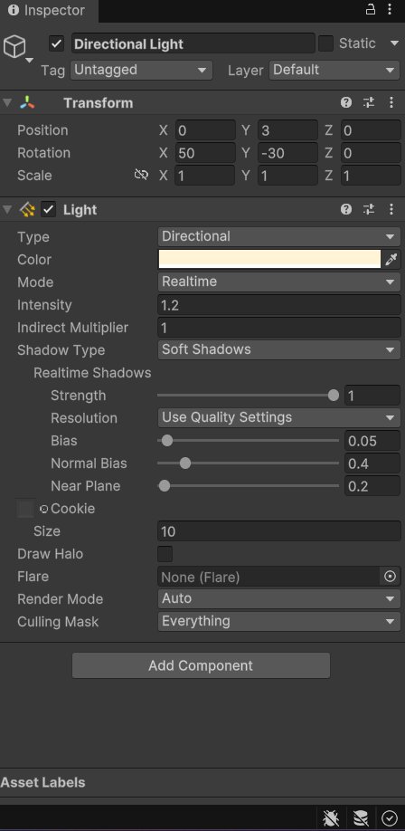

**Task 7:** Add Audio [5 marks]

# Import Your Audio Files

* In project window import the audio file.

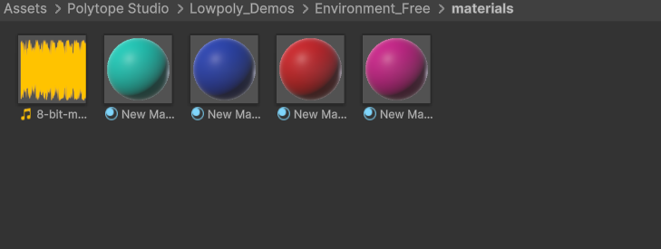

# Add an Audio Source:

* + Select the object.
  + After selecting your GameObject, go to Component > Audio > Audio Source.
  + Now, in the Inspector, you’ll see the Audio Source component. Take your imported audio file and drag it into the Audio Clip field.

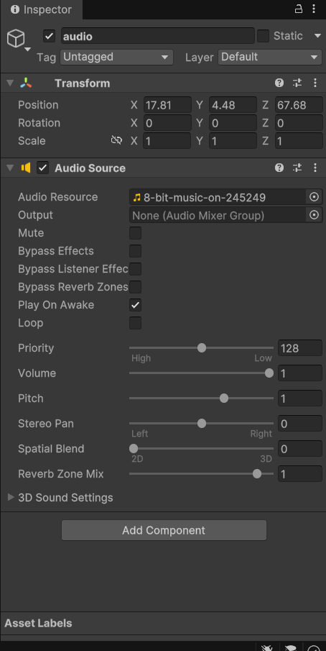

**Task 8:** Implement Basic VR Interaction [25 marks]

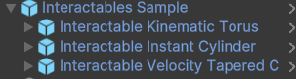

* + - Create a Grabbable Object.
    - Add Grabbable and Grabber Components.

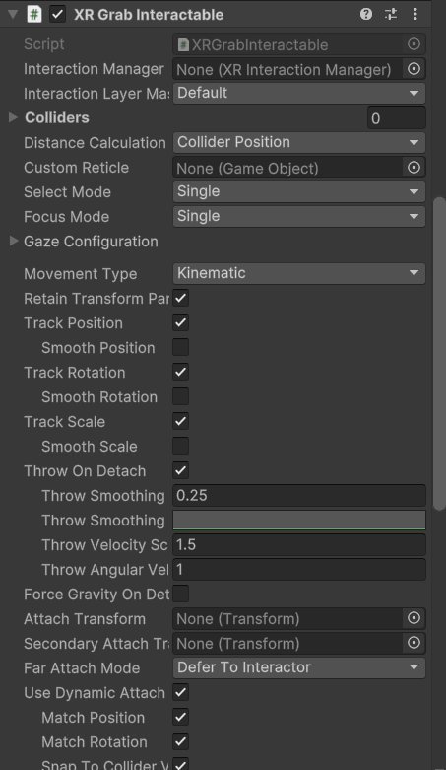

**Task 9:** Write the VR Interaction Script [25 marks]

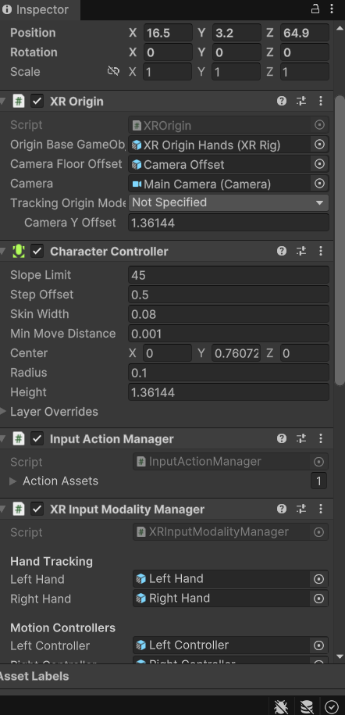

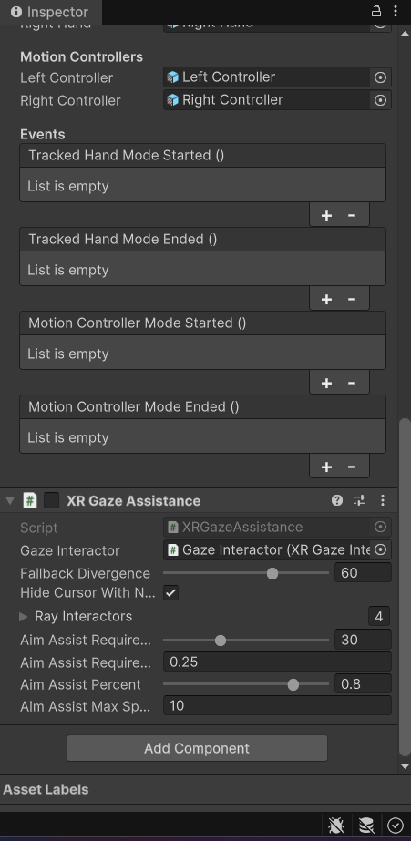

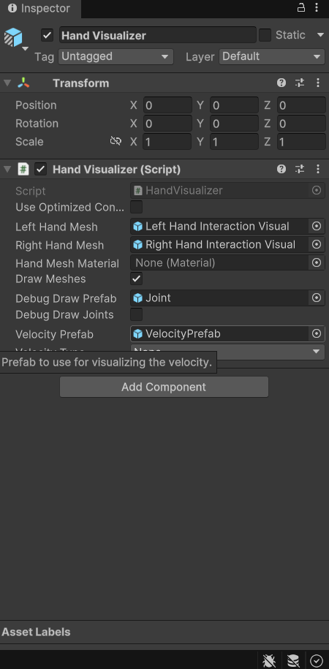

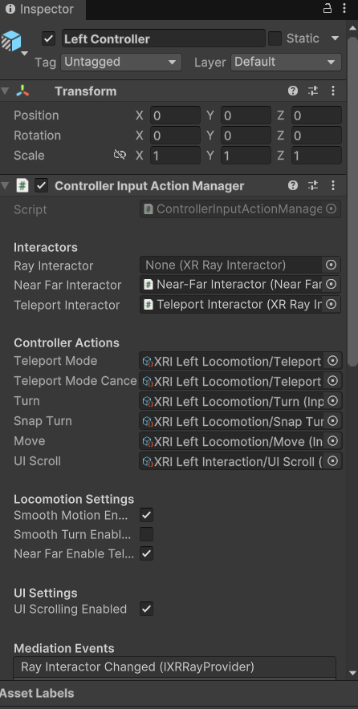

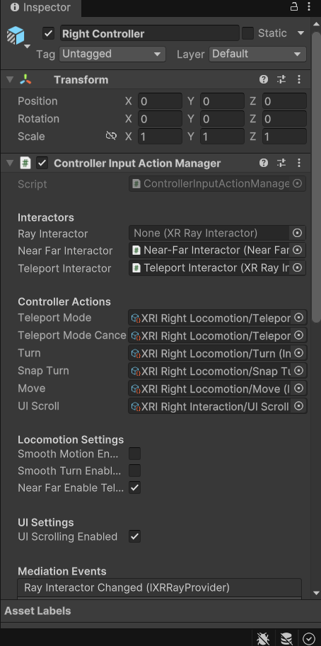

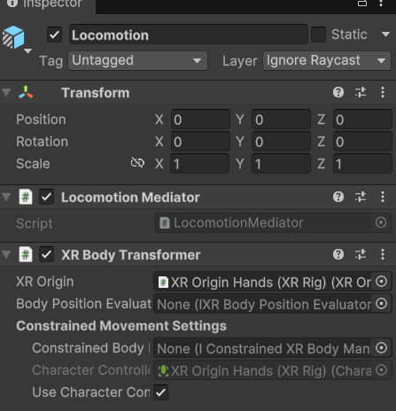

**Task 10:** Demo application [5 marks]

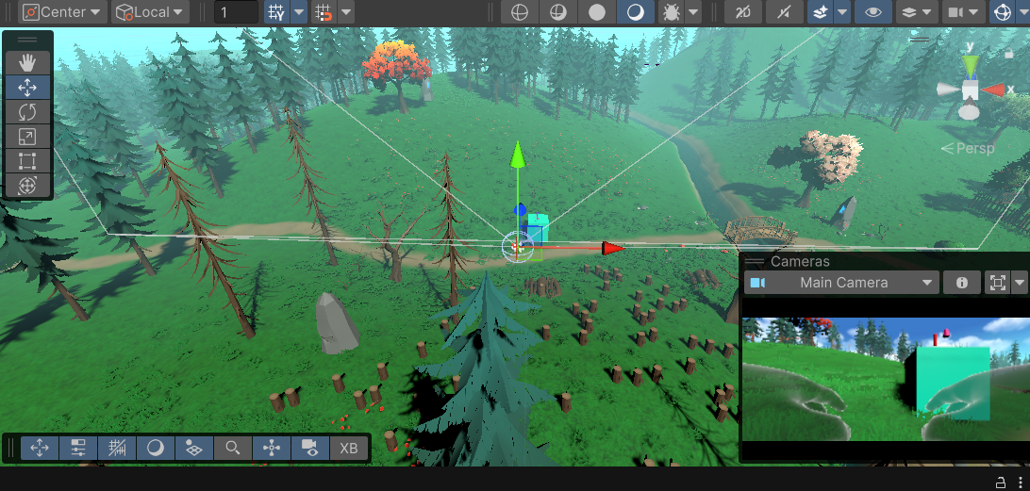

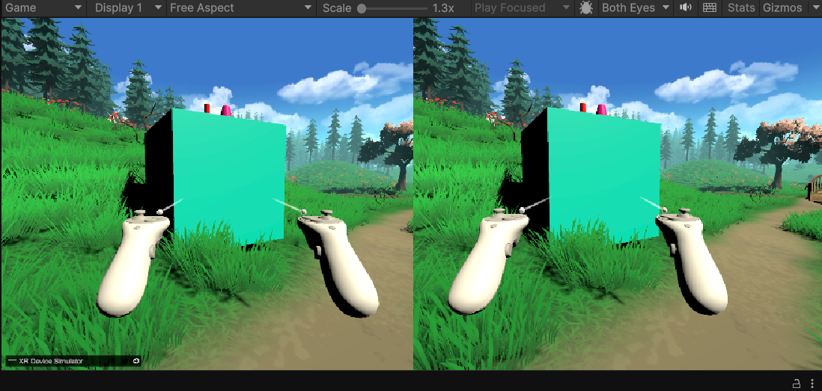

**Tips**

* **Keep it Simple:** Start with basic interactions and gradually add complexity.
* **Feedback:** Provide visual, auditory, and haptic feedback for interactions.
* **Optimization:** Ensure the performance is optimized to prevent lag, which can cause discomfort in VR.
* For more interactiveness you can implement a scoring mechanism.